Advanced CPU Scheduling Algorithms: Implementation & Analysis

Title: Activity Week Assignment (14-12-2025)

Subject: Advanced Operating Systems
Student Number | Core Algorithm | Main Focus and Requirement
6 | Priority Scheduling - Preemptive | Standard Preemptive Priority implementation.

3. General Implementation Requirements

A. Core Logic & Metrics
Your simulator must:
- Be implemented in any programming language you choose (Python, C/C++, Java, etc.).
- Model the execution flow accurately, including ready queue management and preemption checks.
- Compute and output the following metrics for every process and their averages:
  - Completion Time (CT​)
  - Turnaround Time (TAT)
  - Waiting Time (WT​)
  - Response Time (RT​)
Python Program (Preemptive Priority Scheduling)
n = int(input("Enter number of processes: "))
pid = []
arrival = []
burst = []
priority = []
remaining = []
completion = []
waiting = []
turnaround = []
for i in range(n):
print("\nProcess", i + 1)
pid.append(i + 1)
arrival.append(int(input("Arrival Time: ")))
burst.append(int(input("Burst Time: ")))
priority.append(int(input("Priority (lower number = higher priority): ")))
remaining.append(burst[i])
completion.append(0)
waiting.append(0)
turnaround.append(0)
time = 0
completed = 0
while completed < n:
current = -1
highest_priority = 10**9
for i in range(n):
if arrival[i] <= time and remaining[i] > 0:
if priority[i] < highest_priority:
highest_priority = priority[i]
current = i
if current == -1:
time += 1
else:
remaining[current] -= 1
time += 1
if remaining[current] == 0:
completed += 1
completion[current] = time
turnaround[current] = completion[current] - arrival[current]
waiting[current] = turnaround[current] - burst[current]
print("\nPID\tAT\tBT\tPR\tCT\tTAT\tWT")
total_wt = 0
total_tat = 0
for i in range(n):
print(
pid[i], "\t",
arrival[i], "\t",
burst[i], "\t",
priority[i], "\t",
completion[i], "\t",
turnaround[i], "\t",
waiting[i]
)
total_wt += waiting[i]
total_tat += turnaround[i]

print("\nAverage Waiting Time =", total_wt / n)
print("Average Turnaround Time =", total_tat / n)

OUTPUT
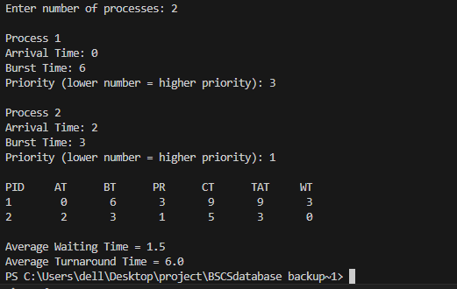

B. Sample Input Data
Use the following data set for the required analysis in your report:
PID | Arrival Time (AT​) | Burst Time (BT​) | Priority (1=Highest)
P1 | 0 | 10 | 3
P2 | 2 | 5 | 1
P3 | 4 | 3 | 4
P4 | 6 | 8 | 2
P5 | 8 | 1 | 5
(Note: For RR and MLFQ assignments, assume a Time Quantum (Q) of 4 for the initial test run.)
Lower priority number means higher priority.
Input Data
PID | AT | BT | Priority
P1 | 0 | 10 | 3
P2 | 2 | 5 | 1
P3 | 4 | 3 | 4
P4 | 6 | 8 | 2
P5 | 8 | 1 | 5

Step by step execution (time wise)
Time 0 to 2
P1 runs
Time 2 to 7
P2 arrives with highest priority and preempts P1
P2 completes
Time 7 to 15
P4 runs (next highest priority)
Time 15 to 23
P1 resumes and completes
Time 23 to 26
P3 runs and completes
Time 26 to 27
P5 runs and completes

Completion Times
PID | Completion Time (CT)
P1 | 23
P2 | 7
P3 | 26
P4 | 15
P5 | 27

Turnaround Time
Turnaround Time = Completion Time minus Arrival Time
PID | TAT
P1 | 23
P2 | 5
P3 | 22
P4 | 9
P5 | 19

Waiting Time
Waiting Time = Turnaround Time minus Burst Time
PID | WT
P1 | 13
P2 | 0
P3 | 19
P4 | 1
P5 | 18

Final Output Table
PID AT BT PR CT TAT WT
P1 0 10 3 23 23 13
P2 2 5 1 7 5 0
P3 4 3 4 26 22 19
P4 6 8 2 15 9 1
P5 8 1 5 27 19 18

Averages
Average Waiting Time
(13 + 0 + 19 + 1 + 18) ÷ 5 = 10.2
Average Turnaround Time
(23 + 5 + 22 + 9 + 19) ÷ 5 = 15.6

Key observations for report
P2 executes immediately due to highest priority
P1 executes in two separate intervals
Low priority processes suffer longer waiting time
Preemptive priority may cause starvation

Python Program of the given Data Above
# Preemptive Priority Scheduling
# Given data set (Priority 1 = Highest)

processes = [
{"pid": "P1", "arrival": 0, "burst": 10, "priority": 3},
{"pid": "P2", "arrival": 2, "burst": 5, "priority": 1},
{"pid": "P3", "arrival": 4, "burst": 3, "priority": 4},
{"pid": "P4", "arrival": 6, "burst": 8, "priority": 2},
{"pid": "P5", "arrival": 8, "burst": 1, "priority": 5},
]

n = len(processes)

remaining = [p["burst"] for p in processes]
completion = [0] * n
turnaround = [0] * n
waiting = [0] * n

time = 0
completed = 0

while completed < n:
current = -1
highest_priority = 10**9

for i in range(n):
if processes[i]["arrival"] <= time and remaining[i] > 0:
if processes[i]["priority"] < highest_priority:
highest_priority = processes[i]["priority"]
current = i

if current == -1:
time += 1
else:
remaining[current] -= 1
time += 1

if remaining[current] == 0:
completed += 1
completion[current] = time
turnaround[current] = completion[current] - processes[current]["arrival"]
waiting[current] = turnaround[current] - processes[current]["burst"]

print("PID\tAT\tBT\tPR\tCT\tTAT\tWT")

total_wt = 0
total_tat = 0

for i in range(n):
print(
processes[i]["pid"], "\t",
processes[i]["arrival"], "\t",
processes[i]["burst"], "\t",
processes[i]["priority"], "\t",
completion[i], "\t",
turnaround[i], "\t",
waiting[i]
)
total_wt += waiting[i]
total_tat += turnaround[i]

print("\nAverage Waiting Time =", total_wt / n)
print("Average Turnaround Time =", total_tat / n)

OUTPUT
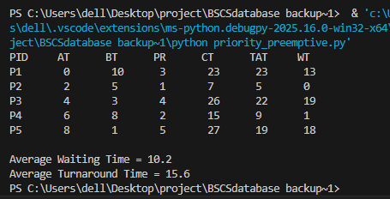

Submission and Documentation

Final Deliverable Requirements:
- Code Upload:
  - The complete source code for your simulator must be uploaded to a public repository (e.g., GitHub or SourceForge).
  - The link to this repository is your primary submission.
- Documentation (README):
  - Your repository must contain a clear README.md file with detailed instructions on how to set up, compile (if necessary), and run your code.
  - Include a summary of your algorithm and any non-standard design choices.
- Formal Report:
  - A formal document (PDF/Google Doc) containing your analysis, manually drawn Gantt chart, results table, and the Advanced Discussion section (as detailed in the earlier requirements).
I will evaluate your work by cloning the repository and running your implementation against a new test case. Ensure your documentation allows for easy execution.

https://github.com/shahidazam2020-oss/priority-preemptive-scheduling2.git

